Hooghly Mohsin College
Health & Hygiene Sub-Committee

COVID awareness activity at college campus during reopening of college after lockdown period
Health & Hygiene Sub-committee always focuses on the overall hygiene and cleanliness inside the campus as well as on the health of our beloved students, teachers and non-teaching staffs. This Sub Committee performed COVID awareness activity for our beloved students, teachers and non-teaching staffs at college campus during reopening of college after lockdown period on 16.11.2021.
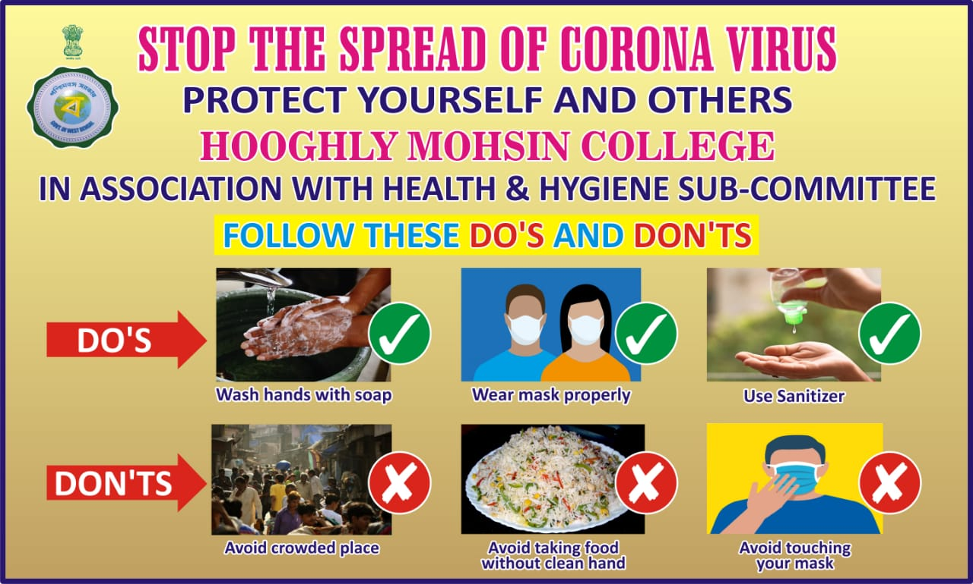
Fig: Poster used as a part of COVID awareness activity

