Hooghly Mohsin College
Health & Hygiene Sub-Committee

COVID-VACCINATION Programme for students and staffs of Hooghly Mohsin College

Recently this Sub Committee has participated actively in the COVID Vaccination Programme (organized by Health & Hygiene Sub-Committee, Hooghly Mohsin College in association of District Administration Health Division & Hooghly Chinsurah Municipality,Govt. of West Bengal) at our college campus on 4th, 5th & 8th October 2021 for our students and staff.
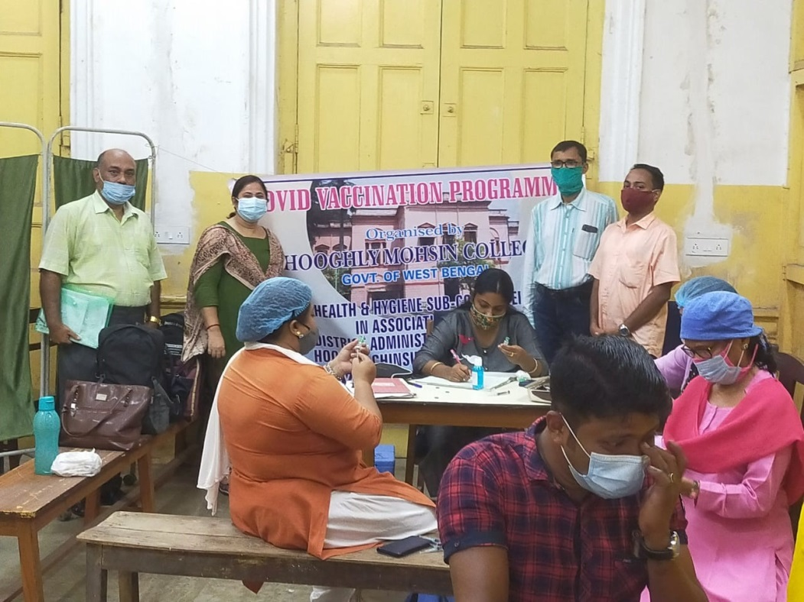
Fig: COVID Vaccination Programme (4th, 5th & 8th October, 2021) at our college campus

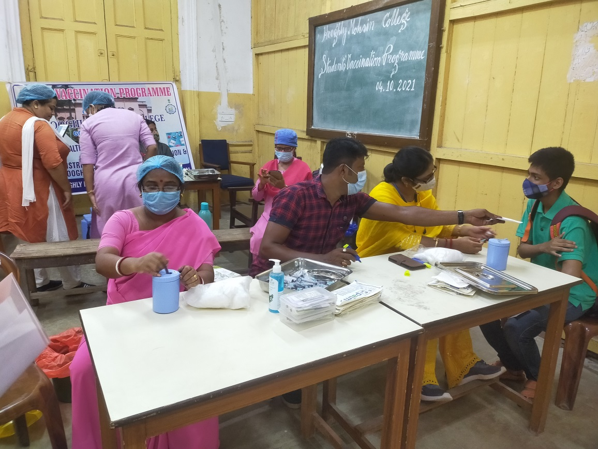
Fig: A student is receiving vaccine during COVID Vaccination Programme.

