Hooghly Mohsin College
Health & Hygiene Sub-Committee
Health & Hygiene Sub-committee is one of the most active committees of our institution. Our institution always focuses on the overall hygiene and cleanliness inside the campus as well as on the health of our beloved students, teachers and non-teaching staffs. Being an active and sincere committee of our institution, Health & Hygiene Sub Committee performs various health awareness programms within college campus. This Sub Committee also performs different health and hygiene related activities outside locality of college campus. This committee organizes seminars/webinars on different health and hygiene related topics throughout the year to promote the fruitful values of health and hygiene amongst the students of our institution.
A Health Awareness Programme was organized by Health & Hygiene Committee at our college campus on 23.09.2021. In this programme, we did general health checkup for example blood pressure measurement, pulse rate, BMI measurement etc. Our students, teachers and other non-teaching staff actively participated in this programme.
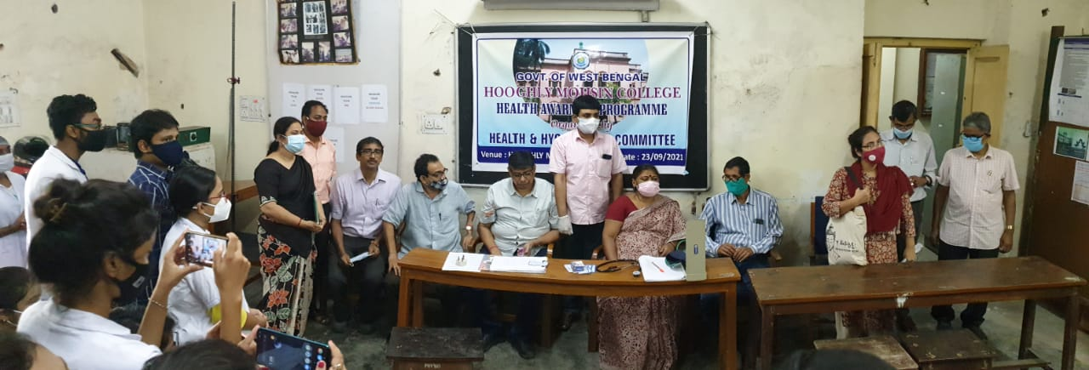

Fig: Health Awareness Programme at our college campus on 23.09.2021

